Atomic Bonding: All chemical bonds involve electrons. Atoms will stay close together if they have a shared interest in one or more electrons. Atoms are at their most stable when they have no partially-filled electron shells. If an atom has only a few electrons in a shell, it will tend to lose them to empty the shell. These elements are metals. When metal atoms bond, a metallic bond occurs. When an atom has a nearly full electron shell, it will try to find electrons from another atom so that it can fill its outer shell. These elements are usually described as nonmetals. The bond between two nonmetal atoms is usually a covalent bond. Where metal and nonmetal atom come together an ionic bond occurs.
Ionic Bonds: Ionic bonding occurs between charged particles. These may be atoms or groups of atoms. Ionic bonding occurs between metal atoms and nonmetal atoms. Metals usually have 1, 2, or 3 electrons in their outermost shell. Nonmetals have 5, 6, or 7 electrons in their outer shell. Atoms with outer shells that are only partially filled are unstable. To become stable, the metal atom wants to get rid of one or more electrons in its outer shell. Losing electrons will either result in an empty outer shell or get it closer to having an empty outer shell.
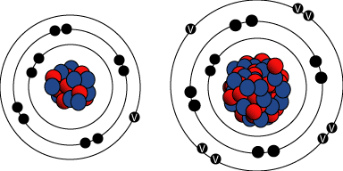
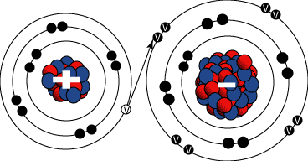
Since electrons have a negative charge, the atom that gains electrons becomes a negatively charged ions because it now has more electrons than protons. Alternately, an atom that loses electrons becomes a positively charged ion. The particles in an ionic compound are held together because there are oppositely charged particles that are attracted to one another.
The images above schematically show the process that takes place during the formation of an ionic bond between sodium and chlorine atoms. Note that sodium has one valence electron that it would like to give up so that it would become stable with a full outer shell of eight. Also note that chlorine has seven valence electrons and it would like to gain an electron in order to have a full shell of eight. The transfer of the electron causes the previously neutral sodium atom to become a positively charged ion (cation), and the previously neutral chlorine atom to become a negatively charged ion (anion). The attraction for the cation and the anion is called the ionic bond. The melting point of NaCl (Ionic Crystal) is 801⁰C, while melting points of metals Na and K are respectively 97.8⁰C & 63⁰C
Generally, solid materials with ionic bonds:
- are hard because particles cannot easily slide past one another.
- are good insulators because there are no free electrons or ions (unless dissolved or melted).
- are transparent because their electrons are not moving from atom to atom and less likely to interact with light photons.
- are brittle and tend to cleave rather than deform because bonds are strong.
- have high melting point because ionic bonds are relatively strong
Covalent Bonding: Where a compound only contains nonmetal atoms, a covalent bond is formed by atoms sharing two or more electrons. Nonmetals have 4 or more electrons in their outer shells (except boron). With this many electrons in the outer shell, it would require more energy to remove the electrons than would be gained by making new bonds. Therefore, both the atoms involved share a pair of electrons. Each atom gives one of its outer electrons to the electron pair, which then spends some time with each atom. Consequently, both atoms are held near each other since both atoms have a share in the electrons.
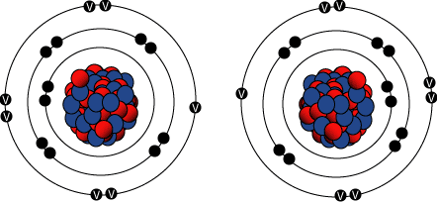
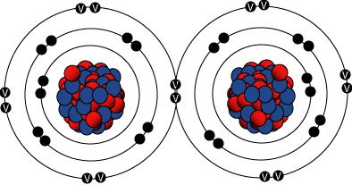
More than one electron pair can be formed with half of the electrons coming from one atom and the rest from the other atom. An important feature of this bond is that the electrons are tightly held and equally shared by the participating atoms. The atoms can be of the same element or different elements. In each molecule, the bonds between the atoms are strong but the bonds between molecules are usually weak. This makes many solid materials with covalent bonds brittle. Many ceramic materials have covalent bonds.
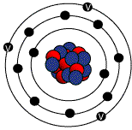
Compounds with covalent bonds may be solid, liquid or gas at room temperature depending on the number of atoms in the compound. The more atoms in each molecule, the higher a compound’s melting and boiling temperature will be. Since most covalent compounds contain only a few atoms and the forces between molecules are weak, most covalent compounds have low melting and boiling points. However, some, like carbon compounds, can be very large. An example is the diamond in which carbon atoms each share four electrons to form giant lattices.
Some Common Features of Materials with Covalent Bonds:
- Hard
- Good insulators
- Transparent
- Brittle or cleave rather than deform
Metallic Bonding: A common characteristic of metallic elements is they contain only one to three electrons in the outer shell. When an element has only one, two or three valence electrons (i.e. electrons in the outer shell), the bond between these electrons and the nucleus is relatively weak. So, for example, when aluminum atoms are grouped together in a block of metal, the outer electrons leave individual atoms to become part of common “electron cloud.” In this arrangement, the valence electrons have considerable mobility and are able to conduct heat and electricity easily. Also, the delocalized nature of the bonds, make it possible for the atoms to slide past each other when the metal is deformed instead of fracturing like glass or other brittle material.
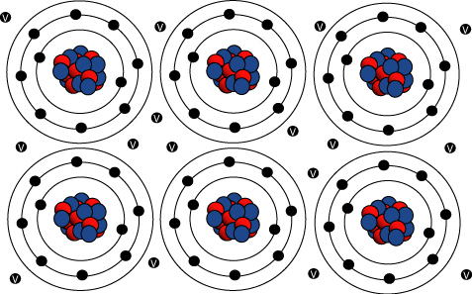
Since the aluminum atoms lose two electrons, they end up having a positive charge and are designated Al³⁺ ions (cations). These ions repel each other but are held together in the block because the negative electrons are attracted to the positively charged ions. A result of the sharing of electrons is the cations arrange themselves in a regular pattern. This regular pattern of atoms is the crystalline structure of metals. In the crystal lattice, atoms are packed closely together to maximize the strength of the bonds. An actual piece of metal consists of many tiny crystals called grains that touch at grain boundaries.
Some Common Features of Materials with Metallic Bonds:
- Good electrical and thermal conductors due to their free valence electrons
- Opaque
- Relatively ductile
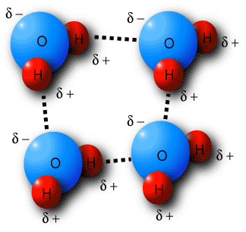
Van der Waals Bond: The van der Waal bonds occur to some extent in all materials but are particularly important in plastics and polymers. These materials are made up of a long string molecules consisting of carbon atoms covalently bonded with other atoms, such as hydrogen, nitrogen, oxygen, fluorine. The covalent bonds within the molecules are very strong and rupture only under extreme conditions. The bonds between the molecules that allow sliding and rupture to occur are called van der Waal forces.
When ionic and covalent bonds are present, there is some imbalance in the electrical charge of the molecule. Take water as an example. Research has determined the hydrogen atoms are bonded to the oxygen atoms at an angle of 104.5°. This angle produces a positive polarity at the hydrogen-rich end of the molecule and a negative polarity at the other end. A result of this charge imbalance is that water molecules are attracted to each other. This is the force that holds the molecules together in a drop of water.
This same concept can be carried on to plastics, except that as molecules become larger, the van der Waal forces between molecules also increases. For example, in polyethylene the molecules are composed of hydrogen and carbon atoms in the same ratio as ethylene gas. But there are more of each type of atom in the polyethylene molecules and as the number of atoms in a molecule increases, the matter passes from a gas to a liquid and finally to a solid.
Polymers are often classified as being either a thermoplastic or a thermosetting material. Thermoplastic materials can be easily remelted for forming or recycling and thermosetting material cannot be easily remelted. In thermoplastic materials consist of long chainlike molecules. Heat can be used to break the van der Waal forces between the molecules and change the form of the material from a solid to a liquid. By contrast, thermosetting materials have a three-dimensional network of covalent bonds. These bonds cannot be easily broken by heating and, therefore, can not be remelted and formed as easily as thermoplastics.

Primary Metallic Crystalline Structures (BCC, FCC, HCP)
There are 14 different types of crystal unit cell structures or lattices are found in nature. However most metals and many other solids have unit cell structures described as body center cubic (bcc), face centered cubic (fcc) or Hexagonal Close Packed (hcp).
Body-Centered Cubic (BCC) Structure: The body-centered cubic unit cell has atoms at each of the eight corners of a cube (like the cubic unit cell) plus one atom in the center of the cube (left image below). Each of the corner atoms is the corner of another cube so the corner atoms are shared among eight unit cells. It is said to have a coordination number of 8. The bcc unit cell consists of a net total of two atoms; one in the center and eight eighths from corners atoms as shown in the middle image below (middle image below). The image below highlights a unit cell in a larger section of the lattice.
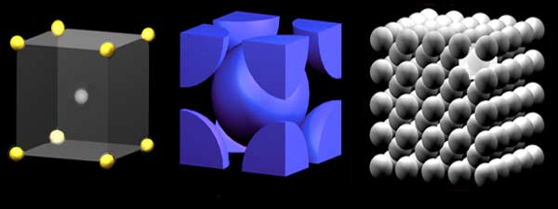
Packing Factor: The bcc arrangement does not allow the atoms to pack together as closely as the fcc or hcp arrangements. The bcc structure is often the high temperature form of metals that are close-packed at lower temperatures. The volume of atoms in a cell per the total volume of a cell is called the packing factor. The bcc unit cell has a packing factor of 0.68.
Some of the materials that have a bcc structure include lithium, sodium, potassium, chromium, barium, vanadium, alpha-iron and tungsten.
Metals which have a bcc structure are usually harder and less malleable than close-packed metals such as gold. When the metal is deformed, the planes of atoms must slip over each other, and this is more difficult in the bcc structure. It should be noted that there are other important mechanisms for hardening materials, such as introducing impurities or defects which make slipping more difficult. These hardening mechanisms will be discussed latter.
Face Centered Cubic (FCC) Structure: The face centered cubic structure has atoms located at each of the corners and the centers of all the cubic faces (left image below). Each of the corner atoms is the corner of another cube so the corner atoms are shared among eight unit cells. Additionally, each of its six face centered atoms is shared with an adjacent atom. Since 12 of its atoms are shared, it is said to have a coordination number of 12. The fcc unit cell consists of a net total of four atoms; eight eighths from corners atoms and six halves of the face atoms as shown in the middle image above. The image below highlights a unit cell in a larger section of the lattice.
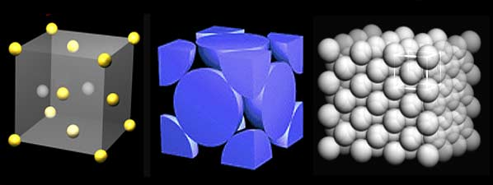
In the fcc structure (and the hcp structure) the atoms can pack closer together than they can in the bcc structure. The atoms from one layer nest themselves in the empty space between the atoms of the adjacent layer.
Packing Factor: To picture packing arrangement, imagine a box filled with a layer of balls that are aligned in columns and rows. When a few additional balls are tossed in the box, they will not balance directly on top of the balls in the first layer but instead will come to rest in the pocket created between four balls of the bottom layer. As more balls are added they will pack together to fill up all the pockets. The packing factor (the volume of atoms in a cell per the total volume of a cell) is 0.74 for fcc crystals. Some of the metals that have the fcc structure include aluminum, copper, gold, iridium, lead, nickel, platinum and silver.
Hexagonal Close Packed (HPC) Structure: Another common close packed structure is the hexagonal close pack. The hexagonal structure of alternating layers is shifted so its atoms are aligned to the gaps of the preceding layer. The atoms from one layer nest themselves in the empty space between the atoms of the adjacent layer just like in the fcc structure. However, instead of being a cubic structure, the pattern is hexagonal. (See image below.)
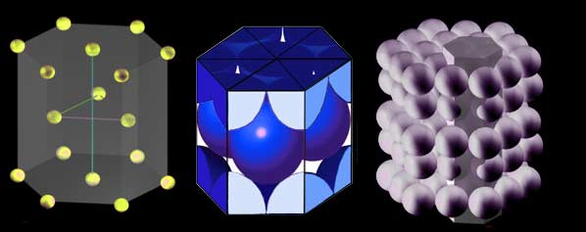
The hcp structure has three layers of atoms. In each the top and bottom layer, there are six atoms that arrange themselves in the shape of a hexagon and a seventh atom that sits in the middle of the hexagon. The middle layer has three atoms nestle in the triangular "grooves" of the top and bottom plane. Note that there are six of these "grooves" surrounding each atom in the hexagonal plane, but only three of them can be filled by atoms.
As shown in the middle image above, there are six atoms in the hcp unit cell. Each of the 12 atoms in the corners of the top and bottom layers contribute 1/6 atom to the unit cell, the two atoms in the center of the hexagon of both the top and bottom layers each contribute ½ atom and each of the three atom in the middle layer contribute 1 atom. The image on the right above attempts to show several hcp unit cells in a larger lattice.
The coordination number of the atoms in this structure is 12. There are six nearest neighbors in the same close packed layer, three in the layer above and three in the layer below. The packing factor is 0.74, which is the same as the fcc unit cell. The hcp structure is very common for elemental metals and some examples include beryllium, cadmium, magnesium, titanium, zinc and zirconium.

Crystal Defects: A perfect crystal, with every atom of the same type in the correct position, does not exist. All crystals have some defects. Defects contribute to the mechanical properties of metals. In fact, using the term “defect” is sort of a misnomer since these features are commonly intentionally used to manipulate the mechanical properties of a material. Adding alloying elements to a metal is one way of introducing a crystal defect. Nevertheless, the term “defect” will be used, just keep in mind that crystalline defects are not always bad. There are basic classes of crystal defects:
- point defects, which are places where an atom is missing or irregularly placed in the lattice structure. Point defects include lattice vacancies, self-interstitial atoms, substitution impurity atoms, and interstitial impurity atoms
- linear defects, which are groups of atoms in irregular positions. Linear defects are commonly called dislocations.
- planar defects, which are interfaces between homogeneous regions of the material. Planar defects include grain boundaries, stacking faults and external surfaces.
It is important to note at this point that plastic deformation in a material occurs due to the movement of dislocations (linear defects). Millions of dislocations result for plastic forming operations such as rolling and extruding. It is also important to note that any defect in the regular lattice structure disrupts the motion of dislocation, which makes slip or plastic deformation more difficult. These defects not only include the point and planer defects mentioned above, and also other dislocations. Dislocation movement produces additional dislocations, and when dislocations run into each other it often impedes movement of the dislocations. This drives up the force needed to move the dislocation or, in other words, strengthens the material. Each of the crystal defects will be discussed in more detail in the following pages.

Specific Heat
The specific heat is the amount of heat per unit mass required to raise the temperature by one degree Celsius. The relationship between heat and temperature change is usually expressed in the form shown below where c is the specific heat. The relationship does not apply if a phase change is encountered, because the heat added or removed during a phase change does not change the temperature.
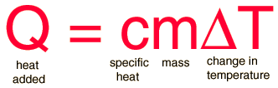

The specific heat of water is 1 calorie/gram °C = 4.186 joule/gram °C which is higher than any other common substance.
Thermal expansion: Thermal expansion is the tendency of matter to change in volume in response to a change in temperature.^{[1]}
When a substance is heated, its particles begin moving more and thus usually maintain a greater average separation. Materials which contract with increasing temperature are rare; this effect is limited in size, and only occurs within limited temperature ranges. The degree of expansion divided by the change in temperature is called the material's coefficient of thermal expansion and generally varies with temperature.

Coefficient of thermal expansion: The coefficient of thermal expansion describes how the size of an object changes with a change in temperature. Specifically, it measures the fractional change in size per degree change in temperature at a constant pressure. Several types of coefficients have been developed: volumetric, area, and linear. Which is used depends on the particular application and which dimensions are considered important. For solids, one might only be concerned with the change along a length, or over some area.
The volumetric thermal expansion coefficient is the most basic thermal expansion coefficient. In general, substances expand or contract when their temperature changes, with expansion or contraction occurring in all directions. Substances that expand at the same rate in every direction are called isotropic. For isotropic materials, the area and linear coefficients may be calculated from the volumetric coefficient.
Mathematical definitions of these coefficients are defined below for solids, liquids, and gasses.

General volumetric thermal expansion coefficient
In the general case of a gas, liquid, or solid, the volumetric coefficient of thermal expansion is given by
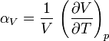
The subscript p indicates that the pressure is held constant during the expansion, and the subscript "V" stresses that it is the volumetric (not linear) expansion that enters this general definition. In the case of a gas, the fact that the pressure is held constant is important, because the volume of a gas will vary appreciably with pressure as well as temperature. For a gas of low density this can be seen from the ideal gas law.

Expansion in solids: Materials generally change their size when subjected to a temperature change while the pressure is held constant. In the special case of solid materials, the pressure does not appreciably affect the size of an object, and so, for solids, it's usually not necessary to specify that the pressure be held constant.
Common engineering solids usually have coefficients of thermal expansion that do not vary significantly over the range of temperatures where they are designed to be used, so where extremely high accuracy is not required, practical calculations can be based on a constant, average, value of the coefficient of expansion.

Linear expansion
The linear thermal expansion coefficient relates the change in a material's linear dimensions to a change in temperature. It is the fractional change in length per degree of temperature change. Ignoring pressure, we may write:
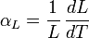
where L is the linear dimension (e.g. length) and dL / dT is the rate of change of that linear dimension per unit change in temperature.
The change in the linear dimension can be estimated to be:
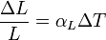
This equation works well as long as the linear expansion coefficient does not change much over the change in temperature ΔT. If it does, the equation must be integrated.

Effects on strain
For solid materials with a significant length, like rods or cables, an estimate of the amount of thermal expansion can be described by the material strain, given by and defined as:
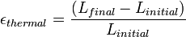
where is the length before the change of temperature and is the length after the change of temperature.
For most solids, thermal expansion is proportional to the change in temperature:
Thus, the change in either the strain or temperature can be estimated by:
where
is the difference of the temperature between the two recorded strains, measured in degrees Celsius or kelvins, and is the linear coefficient of thermal expansion in inverse kelvins.
In physics, thermal conductivity, k, is the property of a material's ability to conduct heat. It appears primarily in Fourier's Law for heat conduction.
Heat transfer across materials of high thermal conductivity occurs at a faster rate than across materials of low thermal conductivity. Correspondingly materials of high thermal conductivity are widely used in heat sink applications and materials of low thermal conductivity are used as thermal insulation.
Thermal conductivity of materials is temperature dependent. In general, materials become more conductive to heat as the average temperature increases.
The reciprocal of thermal conductivity is thermal resistivity, usually measured in kelvin-meters per watt (K·m·W⁻¹). When dealing with a known amount of material, its thermal conductance and the reciprocal property, thermal resistance, can be described. Unfortunately, there are differing definitions for these terms.
The reciprocal of thermal conductivity is thermal resistivity.
In the International System of Units (SI), thermal conductivity is measured in watts per meter kelvin (W/(m·K)).
In the imperial system of measurement thermal conductivity is measured in Btu/(hr·ft⋅F) where 1 Btu/(hr·ft⋅F) = 1.730735 W/(m·K).

